Chart JS Sample
Sample app for the Chart JS widgets, Mendix Studio Pro 10.24.17
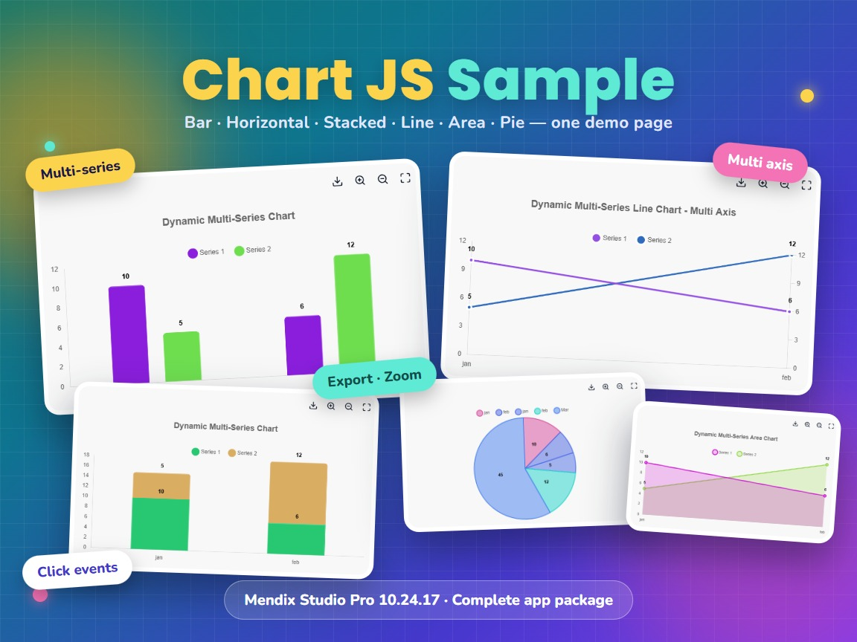
Item | Value
Sample version | 1.0.0 (GitHub release v1.0.0)
Studio Pro version | 10.24.17 (tested on 10.24.17.102810)
Package | Chartjs2.mpk, a complete app package (about 29 MB)
Sample module | ChartJSModule
Widgets included | Chart JS Bar, Line, Area, Pie and ChartJSTwo, all version 1.0.0
Platform | Web, React client
Source and downloads | github.com/bharathidas/ChartJSDemo
Widgets repository | github.com/bharathidas/ChartJS

Contents

1. Overview
Chart JS Sample is a small Mendix app that shows the Chart JS widgets at work. One page, the Dashboard, holds seven charts: four bar charts (grouped, horizontal, stacked, stacked horizontal), an area chart, a line chart with two axes and a pie chart.
Use the sample to see how the widgets are configured before you add them to your own app: how a series gets its data, how the options are set with attributes, and how a click on a chart reaches a microflow.
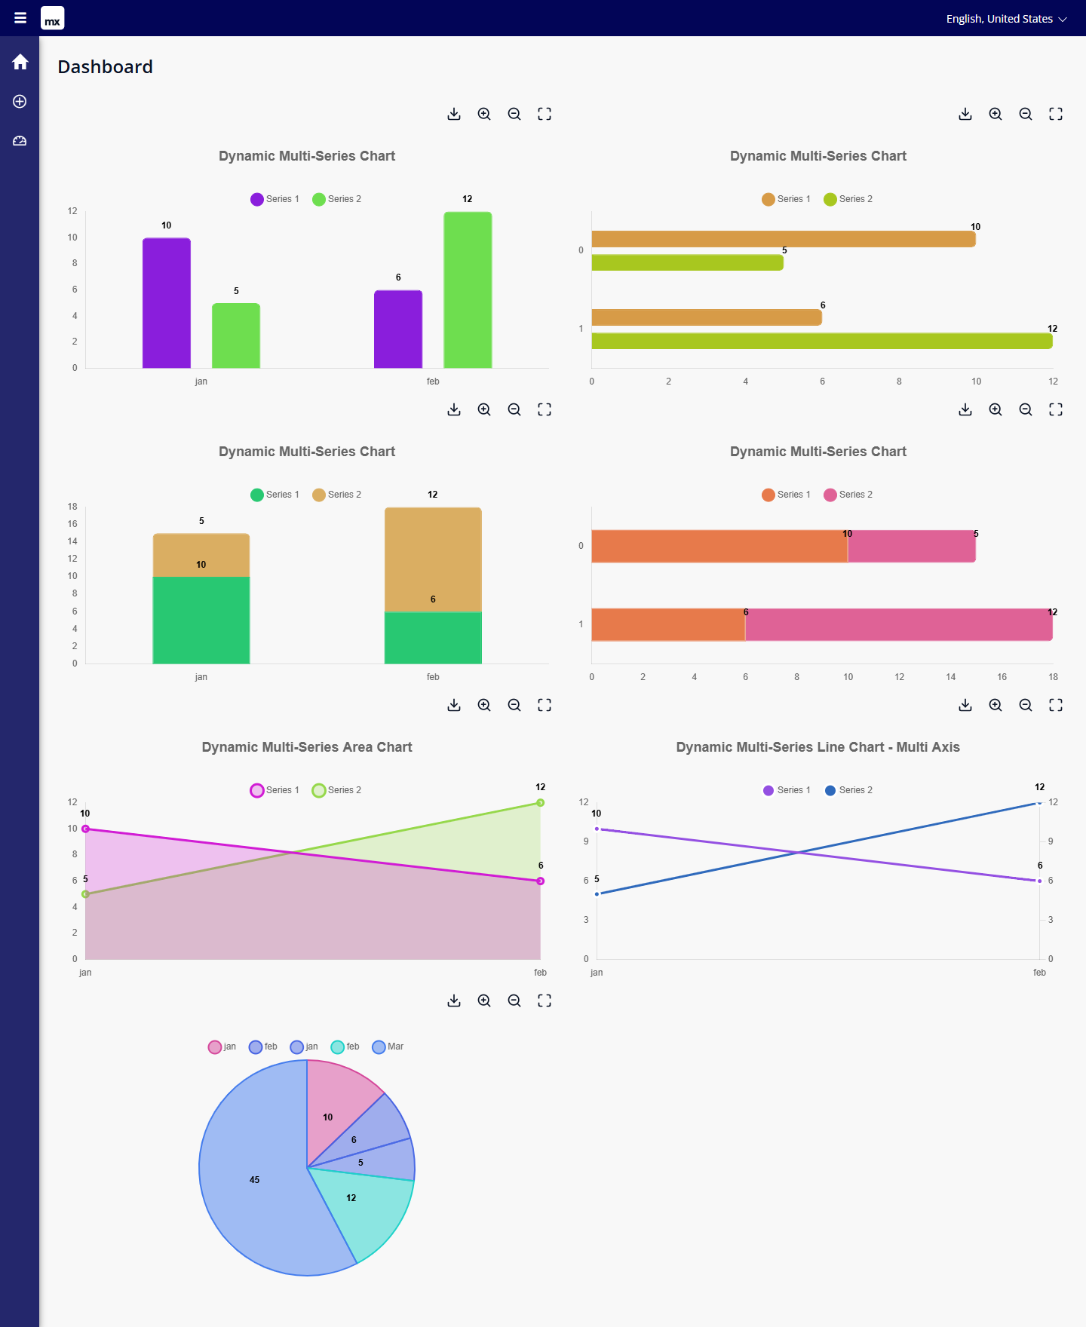
Figure 1. The Dashboard page with all seven charts

What you can learn from it
- How to feed a chart with two series from microflows
- How to feed a pie chart directly from the database
- How to switch options such as stacked, horizontal, values on top, export and zoom with Boolean attributes
- How to react to a click on a bar, point or slice
- How to reuse the four building blocks in your own pages

2. What is new in the 10.24.17 version
- The app is converted from Studio Pro 10.24.6 to 10.24.17. The functionality is unchanged.
- The model check reports 0 errors. It reports 22 warnings, which come from Atlas page templates, building blocks, menu items and a legacy drop-down; they do not stop the app.
- The converted app was started on the Mendix 10.24.17 runtime and the pages were opened in a browser. All seven charts are drawn, the click message appears and the browser console shows no errors. The screenshots in this document are from that run.
- The package is published on GitHub as release v1.0.0.

3. Requirements
- Mendix Studio Pro 10.24.17 or a later 10.24 version.
- A web browser. The sample has a web profile only.
- No login is needed. App security is switched off in the sample.

4. Installation

4.1 Open the sample app
Important: Chartjs2.mpk is a complete app package, not a module package. Do not import it into an existing app with Import module package.
- Download Chartjs2.mpk from the Mendix Marketplace or from the GitHub release v1.0.0.
- In Studio Pro 10.24.17, choose File > Import app package and select the file.
- Choose a folder for the new app and confirm.
- Run the app locally (F5) and open it in the browser (F9).
- Click View Dashboard on the home page.
The package contains a data snapshot with five sample rows, so the charts show data on the first run.

4.2 Use the widgets in your own app
To add the charts to an existing app, do not use this package. Import ChartJSModule.mpk from the Chart JS widgets repository instead:
https://github.com/bharathidas/ChartJS/releases

5. A tour of the app

5.1 Home
The home page has one button, View Dashboard. The menu on the left has three items: Home, Item and Dashboard.
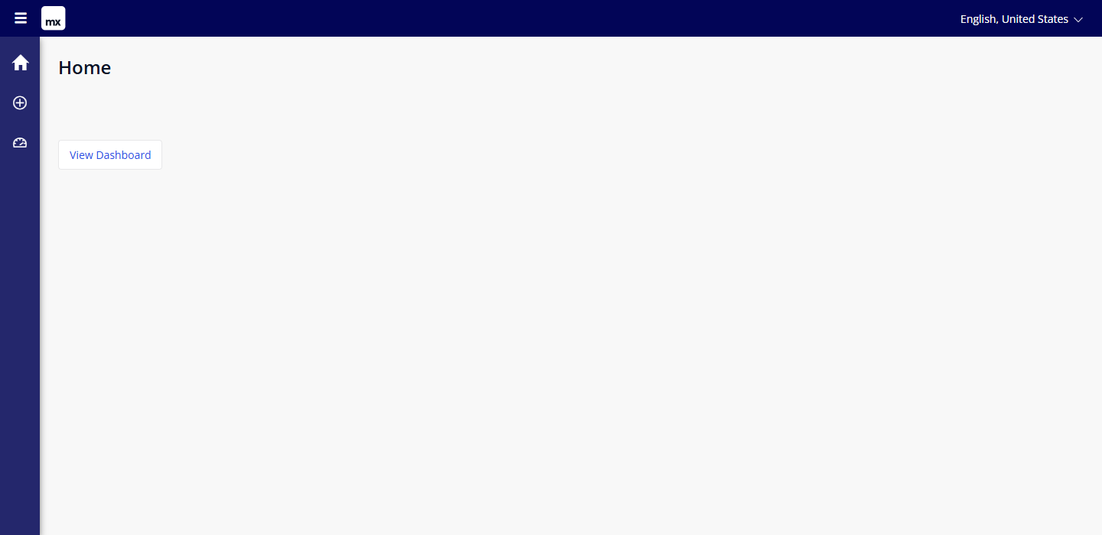
Figure 2. Home page

5.2 Dashboard
The Dashboard is the page ChartJSModule.Example. Every chart has a toolbar with four buttons: Export Chart, Zoom In, Zoom Out and Reset Zoom.
Chart | Widget | Options switched on
Grouped bars | Chart JS Bar | Values on top, export, zoom
Horizontal bars | Chart JS Bar | Horizontal
Stacked bars | Chart JS Bar | Stacked
Stacked horizontal bars | Chart JS Bar | Stacked and horizontal
Area | Chart JS Area | Values on top, export, zoom
Line, multi axis | Chart JS Line | Enable multi axis: each series has its own value axis
Pie | Chart JS Pie | One series with all rows

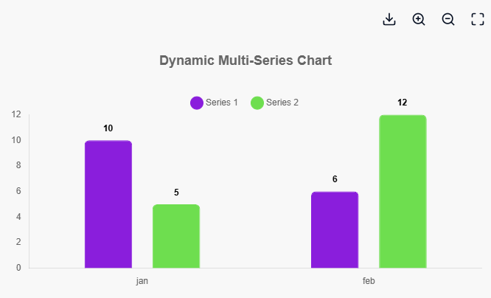
Figure 3. Grouped bar chart with two series
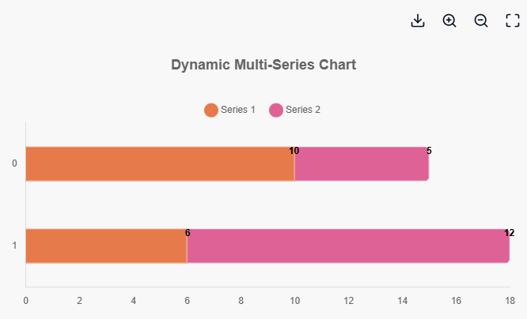
Figure 4. Stacked horizontal bar chart
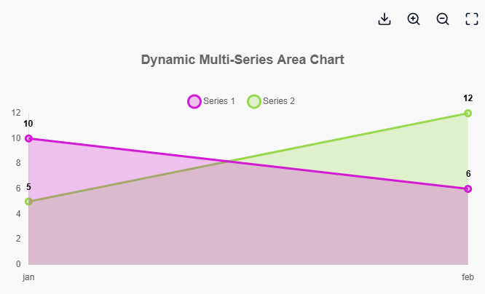
Figure 5. Area chart
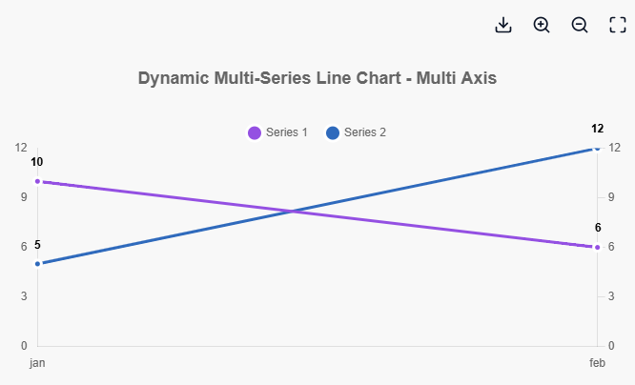
Figure 6. Line chart with one value axis per series
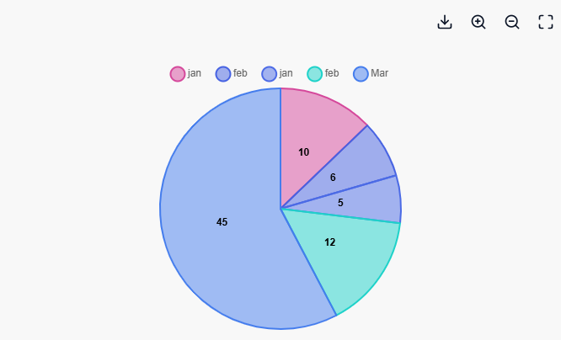
Figure 7. Pie chart with all five rows
When no color attribute is selected, the widgets choose the colors themselves. In the sample the colors are different every time the page is opened.

5.3 Tooltip, zoom and export
Move the mouse over a bar, point or slice to see its label and value. Use the toolbar buttons to zoom in or out, to reset the zoom, and to export the chart.
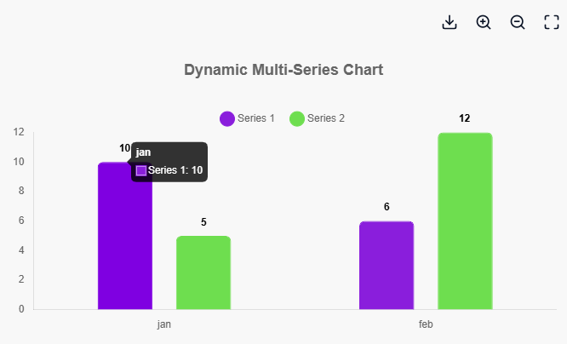
Figure 8. Tooltip on a bar
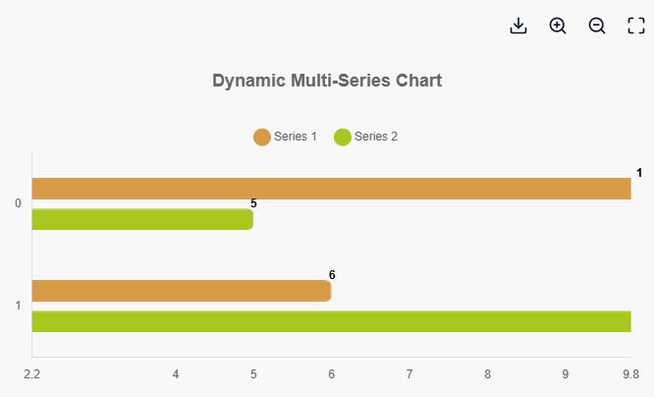
Figure 9. Horizontal bar chart after two clicks on Zoom In

5.4 Click on a chart
A click on a bar, point or slice stores a text such as Label=jan; Value=10; Dataset=Series 1; in the attribute OnClickValue and then runs the microflow testOnClick, which shows that text in a message.
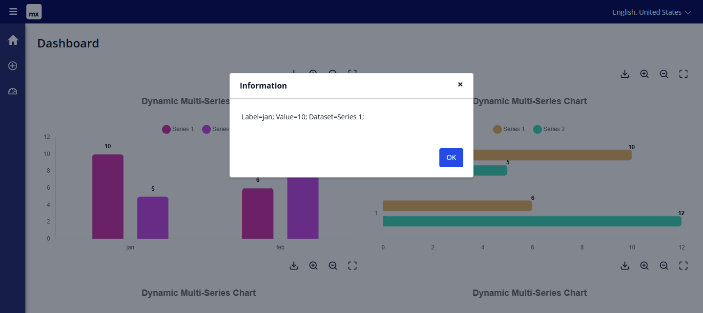
Figure 10. Message after a click on the first bar

5.5 Chart data
The menu item Item opens the page Chart_Overview with the rows that the charts use. Add, change or delete rows here and open the Dashboard again to see the result.
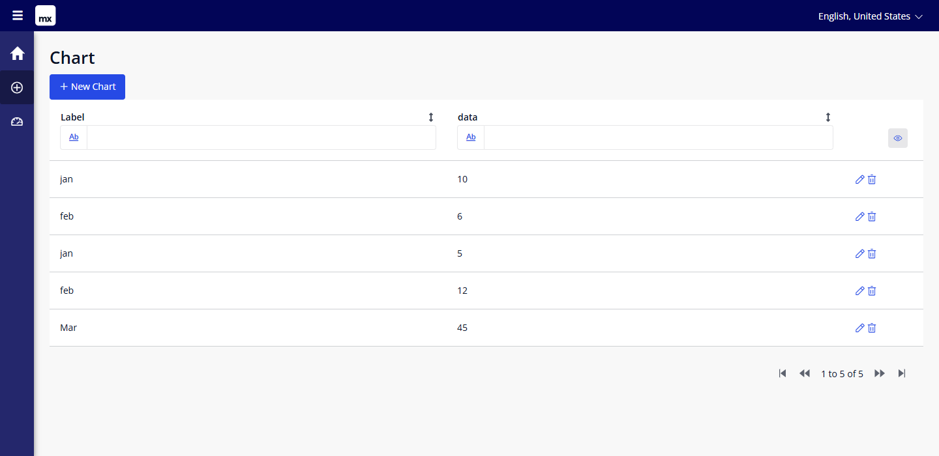
Figure 11. Chart_Overview: the sample rows
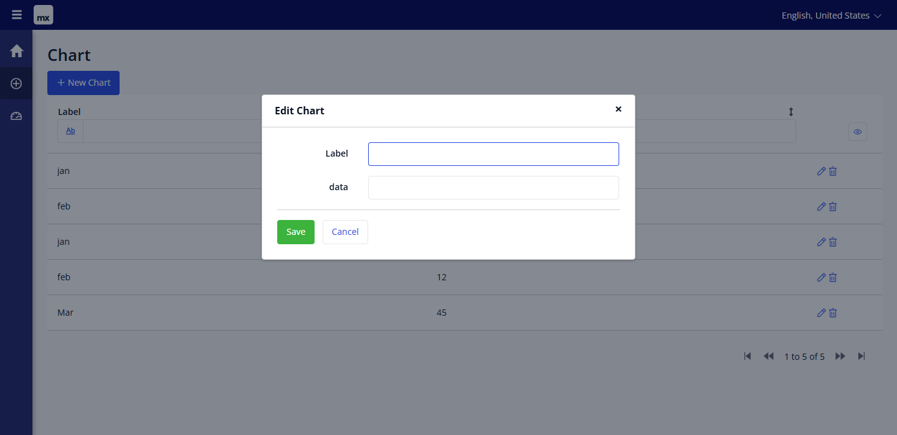
Figure 12. Chart_NewEdit: add or change a row

6. How the sample is built

6.1 Domain model
Entity | Attribute | Type | Purpose
Chart | Label | String | Label of one data point, for example jan
Chart | data | String | Value of the data point as text, for example 10
TestChart | stacked | Boolean (true) | Stacked Bars
TestChart | isHorizontal | Boolean (true) | Horizontal Chart
TestChart | ShowValueonTop | Boolean (true) | Show Values on Top
TestChart | ShowExport | Boolean (true) | Show Export Button
TestChart | ShowZoom | Boolean (true) | Show Zoom Button
TestChart | EnableMultiAxis | Boolean (true) | Multi axis for the line chart
TestChart | OnClickValue | String | Receives the clicked label, value and series

Chart holds the data. TestChart holds the options; the Dashboard creates one TestChart object and all charts read their options from it.

6.2 Microflows
Microflow | What it does
DS_Chart | Data source of the data view on the Dashboard. Creates a TestChart object with the default values (all options true) without committing it.
ACT_Series1 | Returns the first two Chart rows from the database (offset 0, amount 2). Used as Series 1.
ACT_Series2 | Returns the next two Chart rows (offset 2, amount 2). Used as Series 2.
testOnClick | On click action of every chart. Shows the value of OnClickValue in an information message.

Note: the two series microflows retrieve without sorting, so the split into Series 1 and Series 2 depends on the order in which the database returns the rows. Add a sort order when you copy this pattern.

6.3 Pages and building blocks
Document | Purpose
ChartJS.Home_Web | Home page with the View Dashboard button
ChartJSModule.Example | The Dashboard with the seven charts
ChartJSModule.Chart_Overview | Data grid with the Chart rows
ChartJSModule.Chart_NewEdit | Popup to add or change a row
Building blocks ChartJSBar, ChartJSLine, ChartJSArea, ChartJSPie | Ready-made charts that you can drag from the Toolbox onto a page

6.4 How one chart is configured
All charts are inside a data view with the data source microflow DS_Chart. For the first bar chart the widget properties are:
Property | Value in the sample
Series 1 > Data source | Microflow ACT_Series1
Series 1 > Label (X-axis) | Chart.Label
Series 1 > Value (Y-axis) | Chart.data
Series 2 | The same, with microflow ACT_Series2
Show Values on Top | TestChart.ShowValueonTop
Show Export Button | TestChart.ShowExport
Show Zoom Button | TestChart.ShowZoom
on click value | TestChart.OnClickValue
On click action | Microflow testOnClick

The other bar charts add Horizontal Chart (TestChart.isHorizontal) and Stacked Bars (TestChart.stacked). The line chart adds the multi axis option (TestChart.EnableMultiAxis). The pie chart has one series with the Chart entity from the database as data source.
Chart Title, Chart Height, Show Legend, Show Grid, Enable Animation, Series Label and the color property are not set in the sample, so the widgets use their defaults; the default title is "Dynamic Multi-Series Chart".

7. Make it your own

7.1 Change the data
- Open Item in the menu and add rows with a label and a numeric value.
- Open the Dashboard again. The pie chart shows all rows; the other charts show the first four rows as two series of two.

7.2 Change the options
Open the domain model of ChartJSModule and change the default values of the TestChart attributes, for example set ShowZoom to false. Run the app again; the zoom buttons are gone on all charts. To give one chart its own options, set the values in DS_Chart or use a second options object.

7.3 Copy a chart to your own app
- Import ChartJSModule.mpk from the Chart JS widgets repository into your app.
- Drag one of the building blocks from the Toolbox onto a page, inside a data view with your options object.
- Point the series data sources at your own microflows or entities and select the label and value attributes.
- Select the option attributes you need and, if wanted, an on click microflow.

8. Known behaviour and limitations
- This is a demo app, not a module. It cannot be imported into an existing app.
- The value attribute data is a String. Enter numbers only; other text cannot be drawn.
- The sample series are fixed to two rows each (see 6.2). Rows after the fourth appear only in the pie chart.
- Series colors change on every page load because no color attribute is set.
- The widget package ChartJSTwo is included in the widgets folder but is not placed on a page.
- App security is off. Switch it on and add access rules before you use parts of the sample in production.
- The model check shows 22 warnings from Atlas templates, building blocks, menu items without an action and a legacy drop-down.
- Web only; no native mobile profile.
- The public demo link in the GitHub README is a free sandbox and may be asleep or stopped.

9. Support and version history
Report issues, suggestions and feature requests on GitHub:
https://github.com/bharathidas/ChartJSDemo/issues
Sample app and releases:
https://github.com/bharathidas/ChartJSDemo
Sample | Studio Pro | GitHub release | Changes
1.0.0 | 10.24.17 | v1.0.0 | Converted to Studio Pro 10.24.17; runtime and browser check; new documentation, cover and screenshots.
1.0 | 10.24.6 | – | First version of the sample app.

